Pseudo Code:

Start
Input milesDriven
Input gallonsUsed
Set gasMileage = milesDriven/gallonsUsed
Output milesDrive
Output gallonsUsed
Output gasMileage
Stop
Start
Input milesDriven
Input gallonsUsed
Set gasMileage = milesDriven/gallonsUsed
Output milesDriven
Output gallonsUsed
Output gasMileage
Stop

Flowchart: Code:

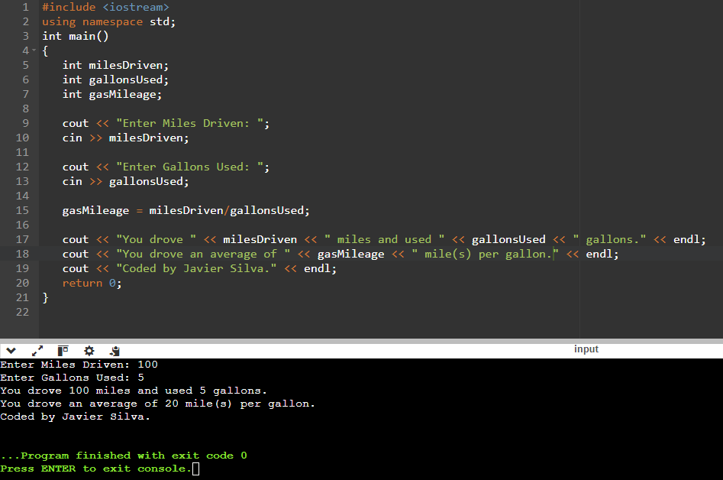
Psuedo Code:

Start
Input roomLength
Input roomWidth
Set carpetArea = roomLength*roomWidth
Output roomLength
Output roomWidth
Output carpetArea
Stop
Start
Input roomLength
Input roomWidth
Set carpetArea = roomLength*roomWidth
Output roomLength
Output roomWidth
Output carpetArea
Stop

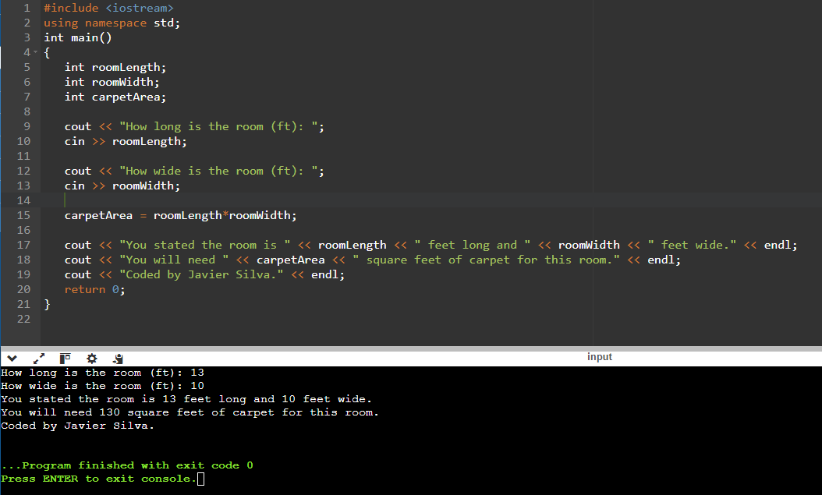
Flowchart: Code:

